1. [SELECT](http://localhost/phpmyadmin/url.php?url=https://dev.mysql.com/doc/refman/8.0/en/select.html) nama_obat, nama_pembuat, stok FROM `obat` JOIN pembuat_obat ON obat.id = pembuat_obat.id WHERE alamat [LIKE](http://localhost/phpmyadmin/url.php?url=https://dev.mysql.com/doc/refman/8.0/en/string-comparison-functions.html#operator_like) '%Jakarta%' ORDER BY obat.id ASC;

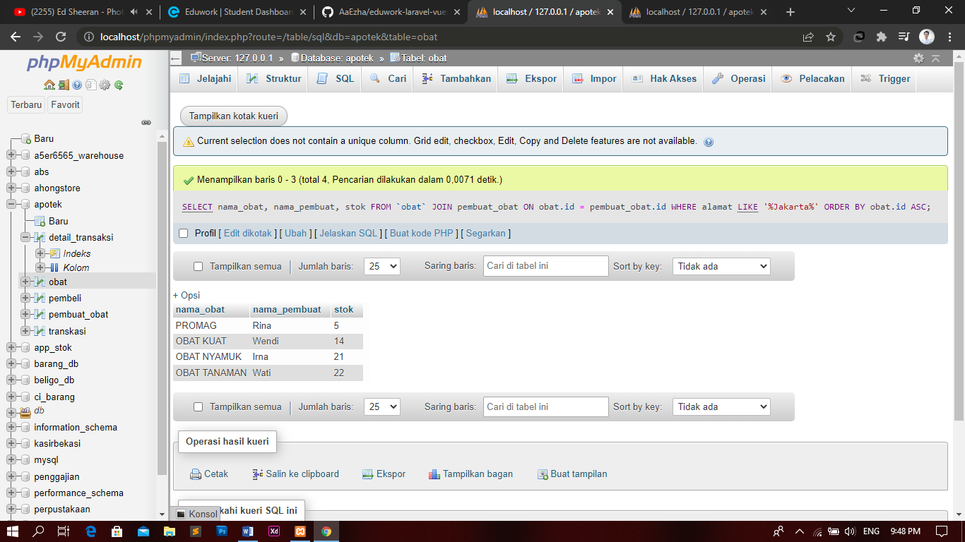

1. [SELECT](http://localhost/phpmyadmin/url.php?url=https://dev.mysql.com/doc/refman/8.0/en/select.html) nama_pasien, jumlah_transaksi FROM `transkasi` JOIN detail_transaksi ON transkasi.id_transaksi = detail_transaksi.id WHERE harga <=50000 ORDER BY detail_transaksi.id ASC;

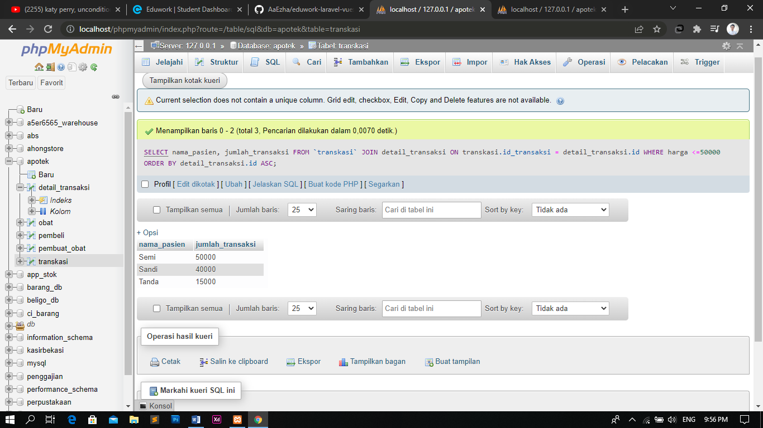

1. [SELECT](http://localhost/phpmyadmin/url.php?url=https://dev.mysql.com/doc/refman/8.0/en/select.html) nama_pasien, jumlah_transaksi FROM `transkasi` JOIN detail_transaksi ON transkasi.id_transaksi = detail_transaksi.id WHERE harga > 25000 ORDER BY detail_transaksi.id ASC;

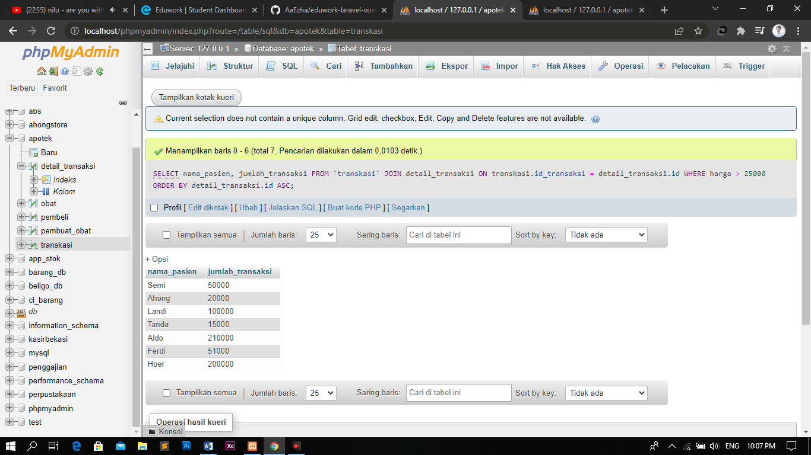

1. [SELECT](http://localhost/phpmyadmin/url.php?url=https://dev.mysql.com/doc/refman/8.0/en/select.html) id, harga FROM `detail_transaksi` JOIN transkasi ON detail_transaksi.id = transkasi.id_transaksi WHERE id [LIKE](http://localhost/phpmyadmin/url.php?url=https://dev.mysql.com/doc/refman/8.0/en/string-comparison-functions.html#operator_like) '2' ORDER BY detail_transaksi.id ASC;

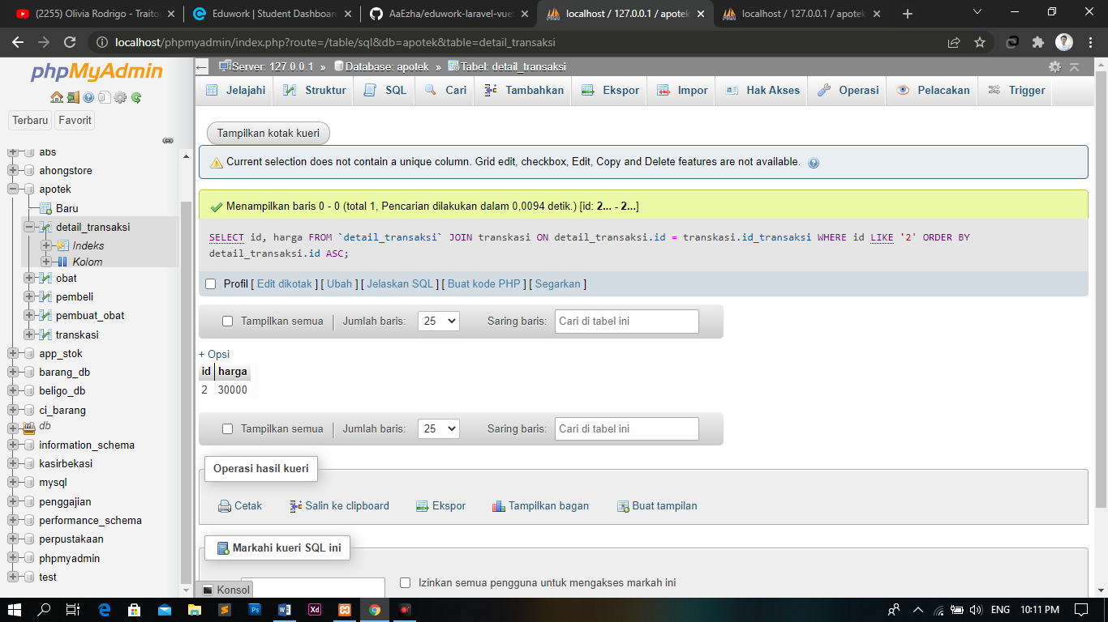

1. [SELECT](http://localhost/phpmyadmin/url.php?url=https://dev.mysql.com/doc/refman/8.0/en/select.html) nama, tanggal_lahir, no_tlp FROM `pembuat_obat` JOIN obat ON pembuat_obat.id = obat.id WHERE alamat [LIKE](http://localhost/phpmyadmin/url.php?url=https://dev.mysql.com/doc/refman/8.0/en/string-comparison-functions.html#operator_like) 'Jakarta Barat' ORDER BY obat.id ASC;

